1stopProject1REPORT

**ABSTRACT:**

Electronic Commerce is process of doing business through computer networks. A person sitting on his chair in front of a computer can access all the facilities of the Internet to buy or sell the products.

Unlike traditional commerce that is carried out physically with effort of a person to go & get products, ecommerce has made it easier for human to reduce physical work and to save time.    E-Commerce which was started in early 1990’s has taken a great leap in the world of computers, but the fact that has hindered the growth of e-commerce is security. Security is the challenge facing e-commerce today & there is still a lot of advancement made in the field of security.

The main advantage of e-commerce over traditional commerce is the user can browse online shops, compare prices and order merchandise sitting at home on their PC.

OBJECTIVE:

The term e-commerce was coined back in the 1960s, with the rise of “Electronic Commerce” the buying and selling of goods through the transmission of data which was made possible bythe introduction of the electronic data interchange. Main objectives of e-commerce are as follows.

1. Reducing the management Cost
2. Developing Business relationship
3. Increase the number of loyal customers
4. Boosting the efficiency of Services
5. Making Responsive E-commerce website
6. Increasing Sales

Need of the study:

Not so long ago, it was uncommon for companies to have websites. Today, e-commerce sees billions of dollars traded annually. No large company with any commercial presence can afford to be without a website. For many companies, their presence on the internet is their window to the world. Some companies operate solely as e-commerce businesses. While all websites are unique, there are seven elements that every website site should have to stay relevant and competitive.

Ubiquity means that the commercial transaction or activity is available at any time from anywhere in the world. Today consumers rely heavily on their cell phones and tablets to access the internet. So make sure that your website is mobile friendly. Having a responsive website that intuitively adapts to whatever device is accessing it provides a user friendly experience

E-commerce allows your company to reach consumers anywhere in the world. Global reach, or world wide access, is the highest number of potential consumers a business can reach. Of course, when working globally, security is key. You must protect your customers’ information and ensure their privacy with a secure e-commerce platform. Security features should include a Secure Sockets Layer certificate that establishes secure connectivity, two-factor authentication, a firewall and a privacy policy.

Interactivity is the relationship a consumer has with your site. It corresponds to face to face customer meetings in traditional business transactions. Increasing the amount of interactivity you have with a consumer lies, in part, on your ability to connect with them on an emotional level. This creates brand trust and loyalty. Make sure your social marketing efforts are linked to your e-commerce site. Engage with your customers. It shows authenticity and they won’t feel like they are just being sold to all the time.

Richness refers to the amount of content on your website and how it’s used by consumers. To ensure richness on your site, provide a variety of messages and means to enhance the shopper’s experience. Videos, text, pictures, sound and links can all enhance the customer experience. Make sure you have high-resolution photos and video. Feature multiple images to help customers get a better feel for your products. Images make the sale, not text. Also make sure that all images load quickly to the page.

**Introduction:**

***Before we start lets understand what is an E-commerce business, and what are the steps to start an E-commerce project***

***Whether you are looking to start an e-commerce business or you are already running e-commerce and looking to explore more about the industry to revamp your business model. This guide will help you get all the essential basics of e-commerce and step to step process to start an e-commerce business in India.***

***E-commerce also, known as electronic commerce refers to all types of the transaction of goods and services conducted online. If you are ordering a household item from Amazon or buying all of your fashion accessories from Flipkart. Even if you are paying for your Spotify & Netflix subscription every month you’re involved in e-commerce. Whenever someone buys or sells any kind of product or service online, they are engaging in e-commerce.***

***The e-commerce industry is growing rapidly globally, every business focusing on bringing their product or service online to reach global audiences. Which result you can buy almost anything online at your convenience, and that ease is not available in the traditional shopping. The first e-commerce transaction was done on August 11, 1994, a man sold a CD by the band Sting through his website NetMarket. According to a study people worldwide purchased $2.86 trillion on the web in 2018 and Global retail e-commerce sales are projected to reach $27 trillion by 2020.***

**Methodology:**

***E-Commerce strategy methodology development and implementation***

***Design team member: Winnie Lam***

***Supervisor: Dr. Norman Ball***

***Background***

***There has been a lot of media coverage on E-Commerce in recent years. However, the concept of E-Commerce is still unclear to many people due to its newness. For business executives, it is even more mysterious since there are no proven business models for generating profits. Conducting research in the E-Commerce area reveals a few dominant trends:***

***E-Commerce revenues will grow explosively.***

***E-Commerce is crucial for business survival.***

***E-Commerce decisions are complex.***

***Consulting firms are experiencing rapid declines in key practice areas.***

***The implications for these trends are as follows:***

***Organizations feel the need for expert advice.***

***E-Commerce is the new business opportunity for consulting firms.***

***Consulting firms need structured, proven, E-Commerce methodologies.***

***These trends and implications are the driving forces for the project.***

***Project description***

***For consulting firms to effectively develop E-Commerce strategies for its clients, it must have a structured methodology custom made for this type of project. As with any methodology, however, this E-Commerce strategy methodology will require constant refinement to incorporate new experiences and to keep pace with change.***

***Thus, this project aims to develop the first version of an E-Commerce strategy methodology, implement the methodology for a client, and make any necessary revisions to the methodology subsequent to the client project.***

***Design methodology***

***The five phases of the project are as follows:***

***Scoping and planning***

***This phase focuses on the planning of the project’s overall direction, including the definition of the project’s scope, objectives, and timelines. The deliverable from this phase is this Design Plan.***

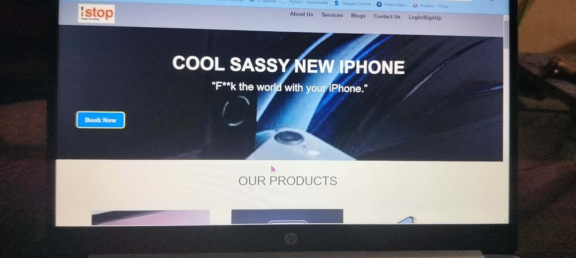

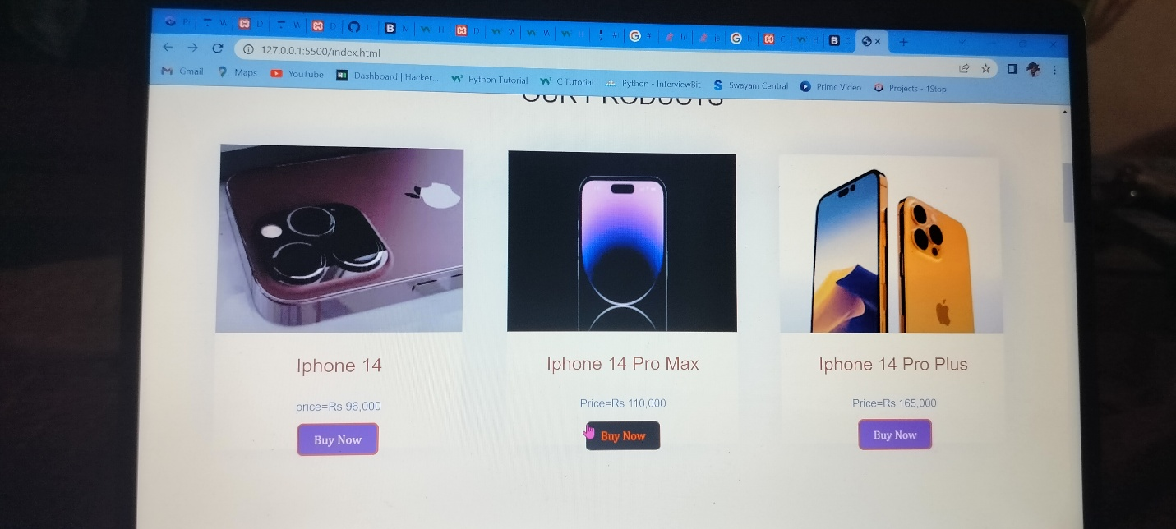

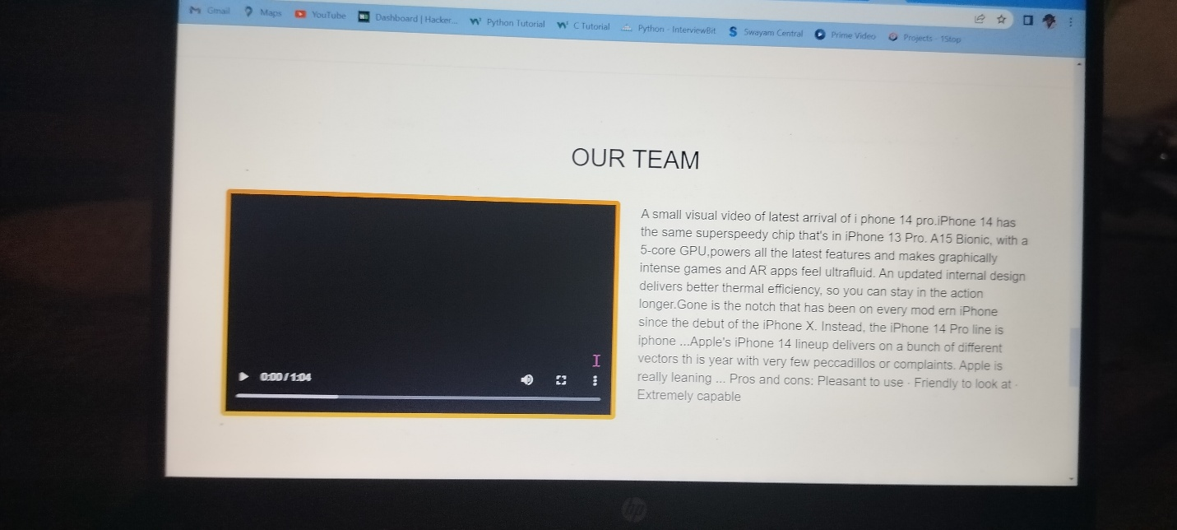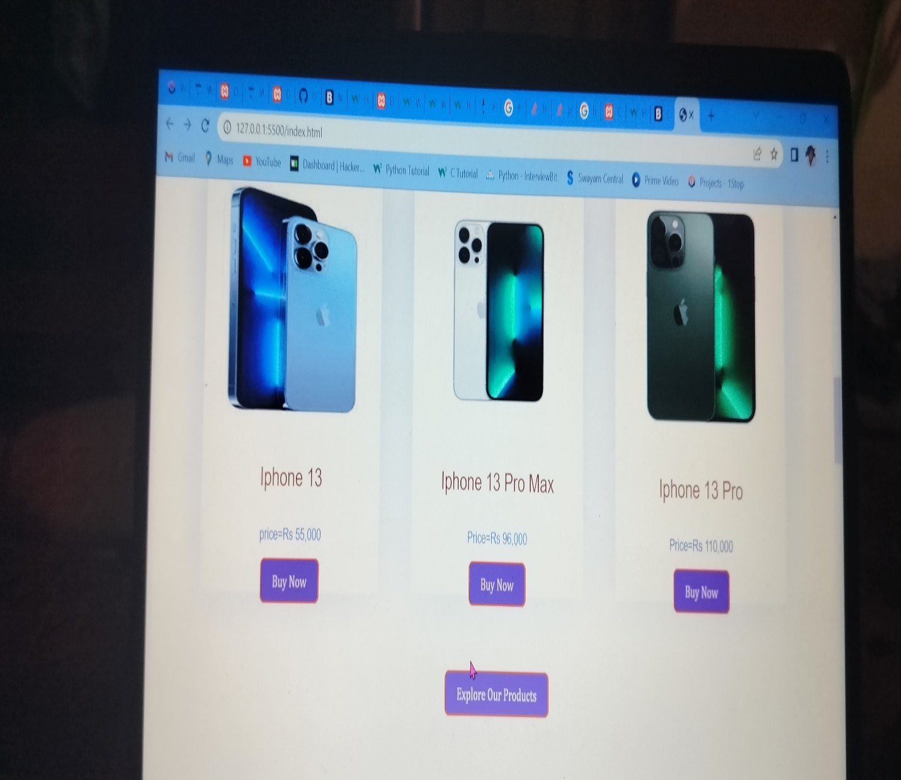

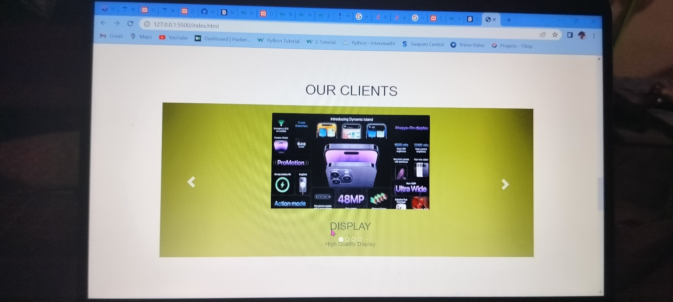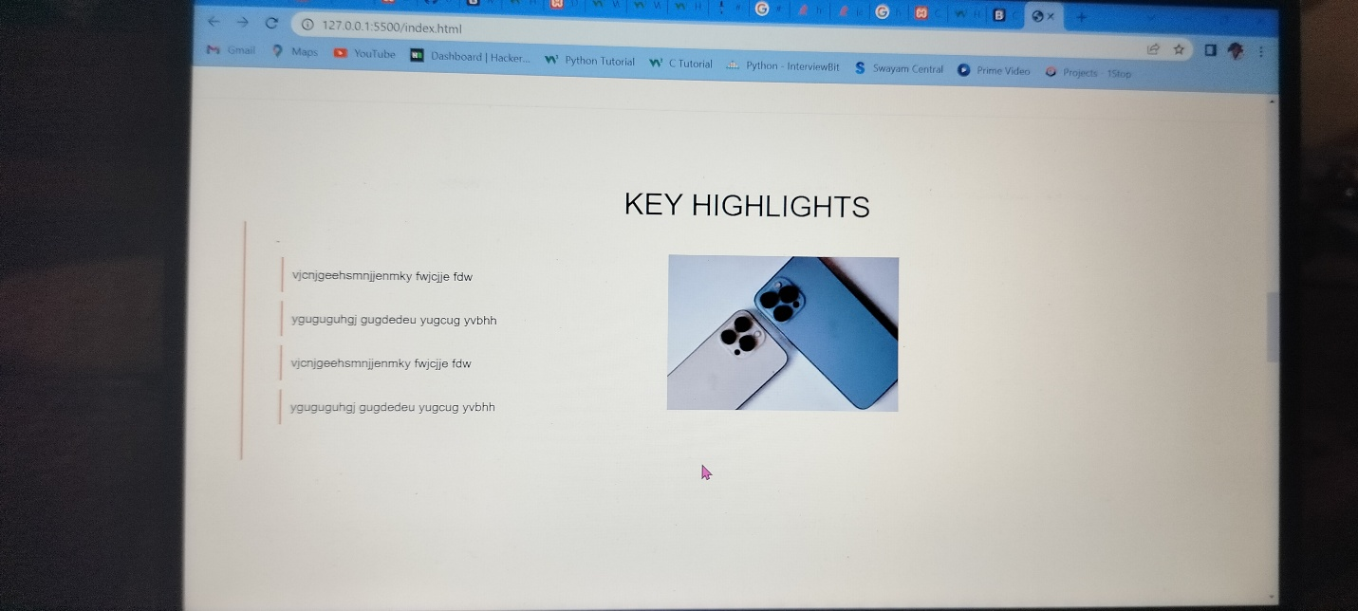

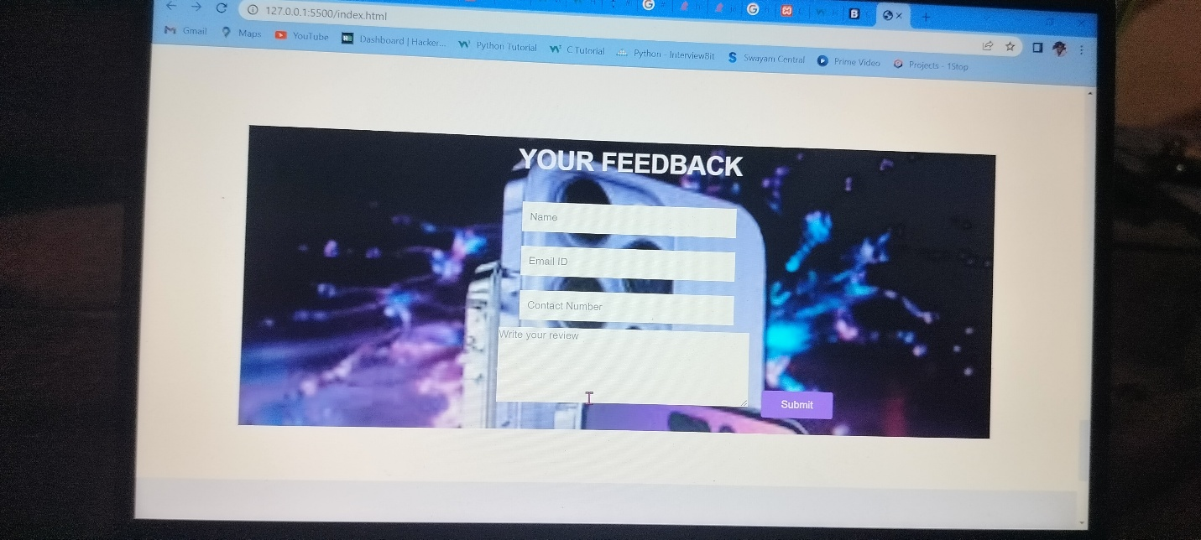

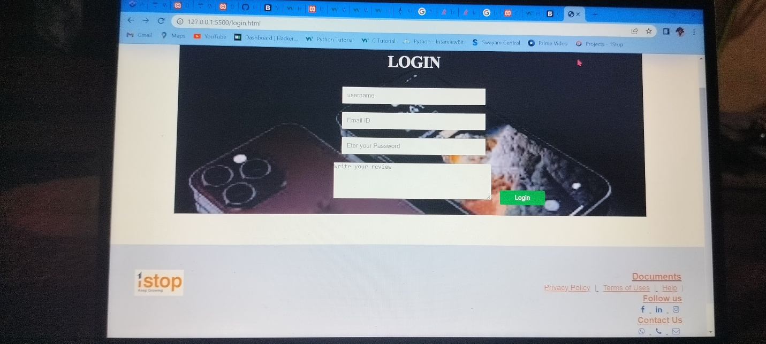

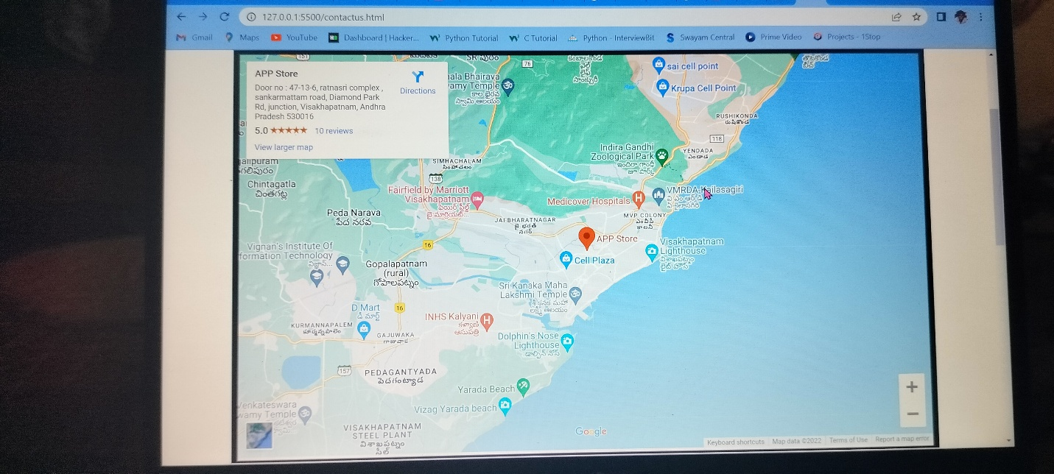

Conclusion:

Conclusion

In general, today’s businesses must always strive to create the next best thing that consumers will want because consumers continue to desire their products, services etc. to continuously be better, faster, and cheaper. In this world of new technology, businesses need to accommodate to the new types of consumer needs and trends because it will prove to be vital to their business’ success and survival. E-commerce is continuously progressing and is becoming more and more important to businesses as technology continues to advance and is something that should be taken advantage of and implemented.

From the inception of the Internet and e-commerce, the possibilities have become endless for both businesses and consumers. Creating more opportunities for profit and advancements for businesses, while creating more options for consumers. However, just like anything else, e-commerce has its disadvantages including consumer uncertainties, but nothing that can not be resolved or avoided by good decision-making and business practices.

There are several factors and variables that need to be considered and decided upon when starting an e-commerce business. Some of these include: types of e-commerce, marketing strategies, and countless more. If the correct methods and practices are followed, a business will prosper in an e-commerce setting with much success and profitability.

Advertisements

REPORT THIS AD